**WPL LAB 6**

Name: Abhinav Singh Bhagtana

Roll no: A-029

Reg no: 230905225

Q1. Develop a simple web page to perform basic arithmetic operations. Take two

integer inputs from the user, select the operation to be performed using a

dropdown. Include a button “Calculate” to perform the selected operation, and

then display the result in the same web page.

Views.py

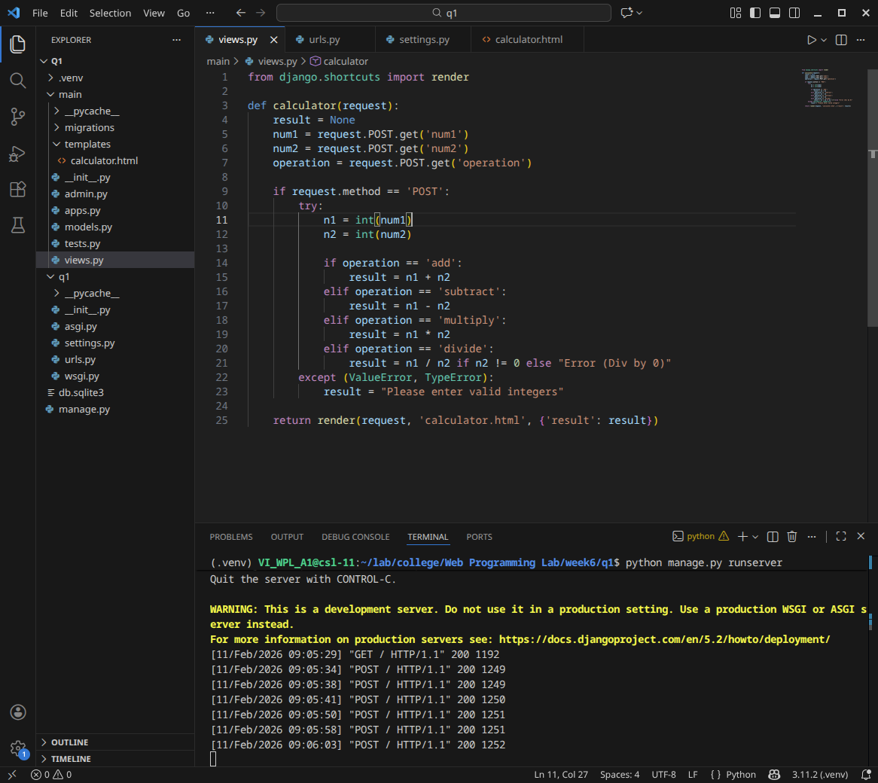

Urls.py

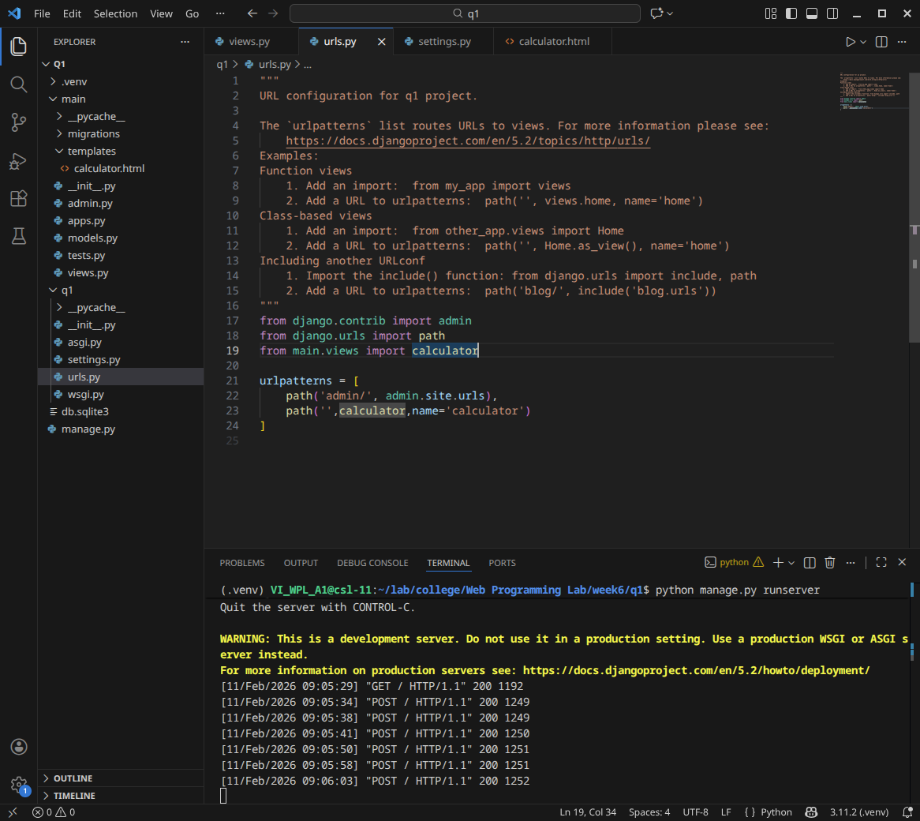Settings.py

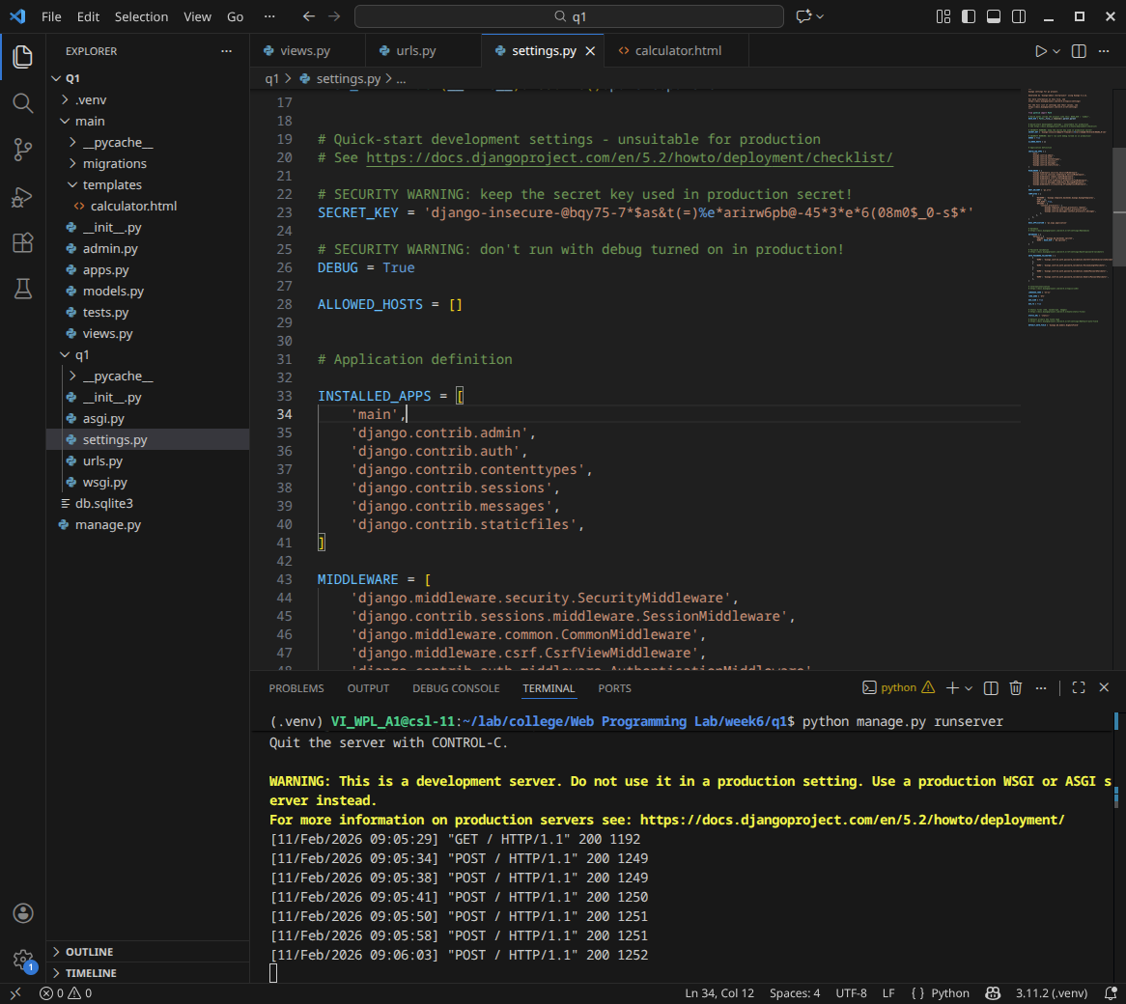Calculator.html

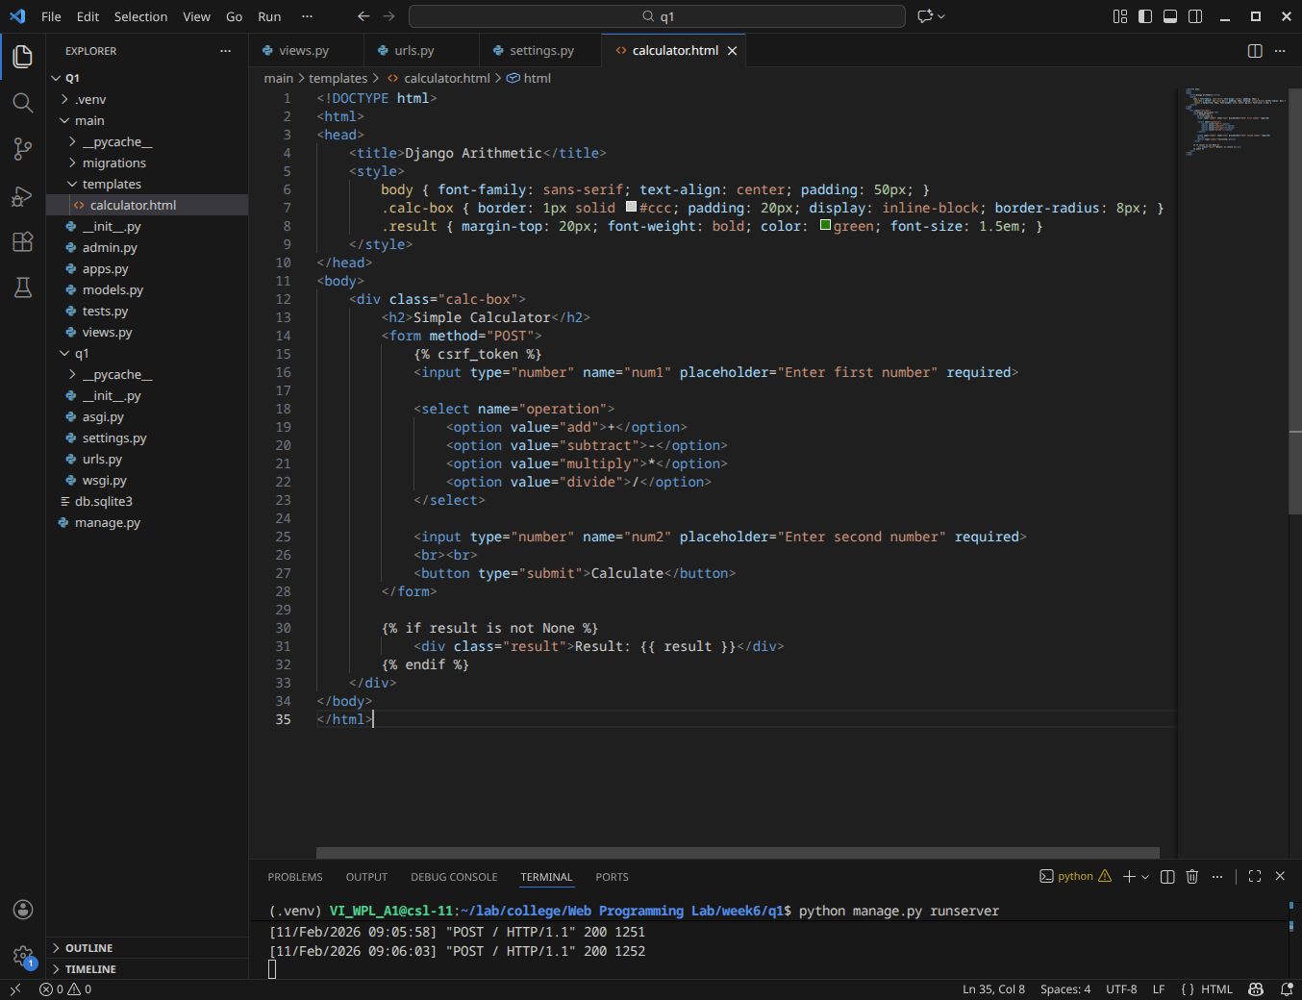Website

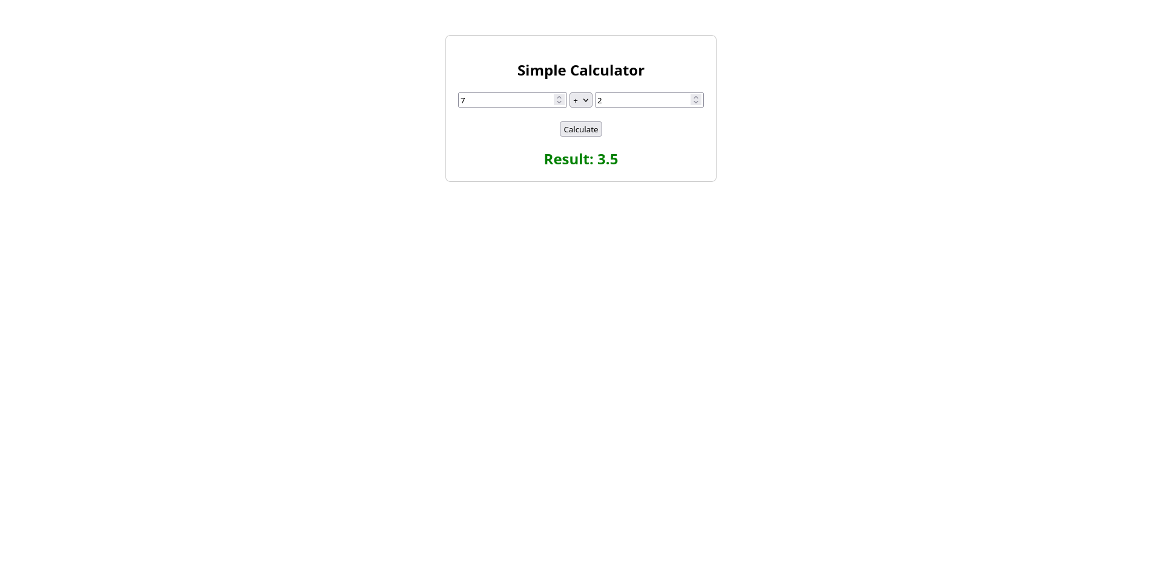

Q2. Develop a simple web form that generates the front cover for a magazine. The

form should provide the options for selecting the image, background color,

changing font size, color etc. Input messages must be taken from the user so

as to display it on the front cover with legible font family and font size. The

front cover developed should be proportionate to the web page size. Place the

css files inside static folder.

Settings.py

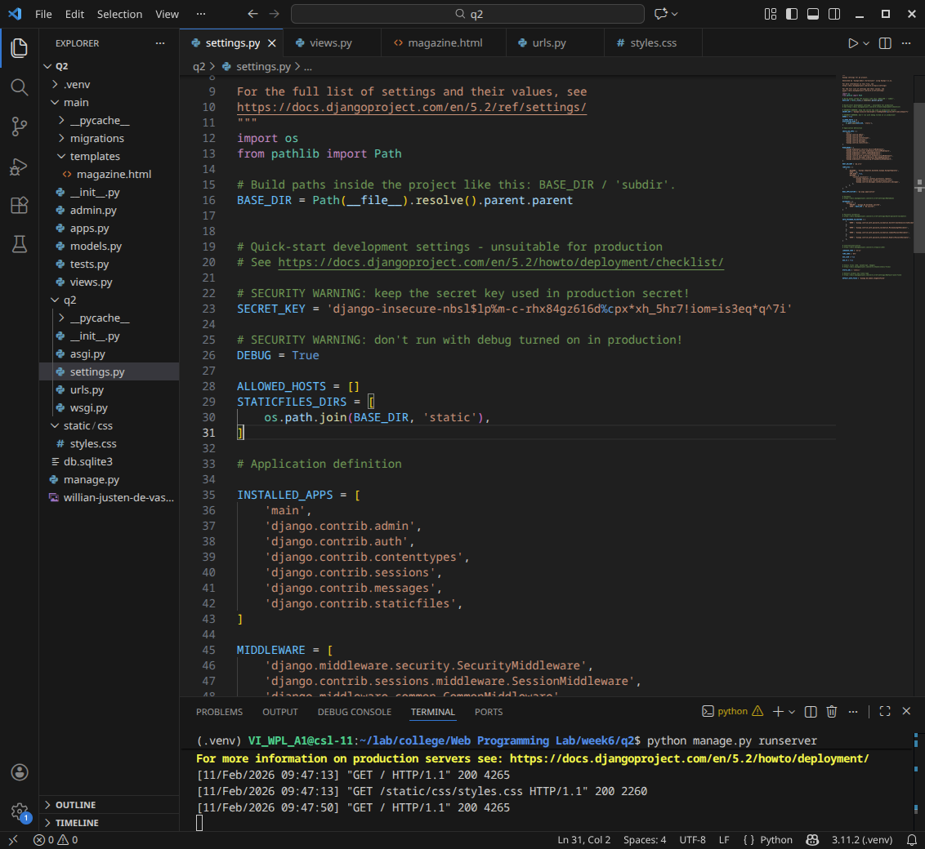Views.py

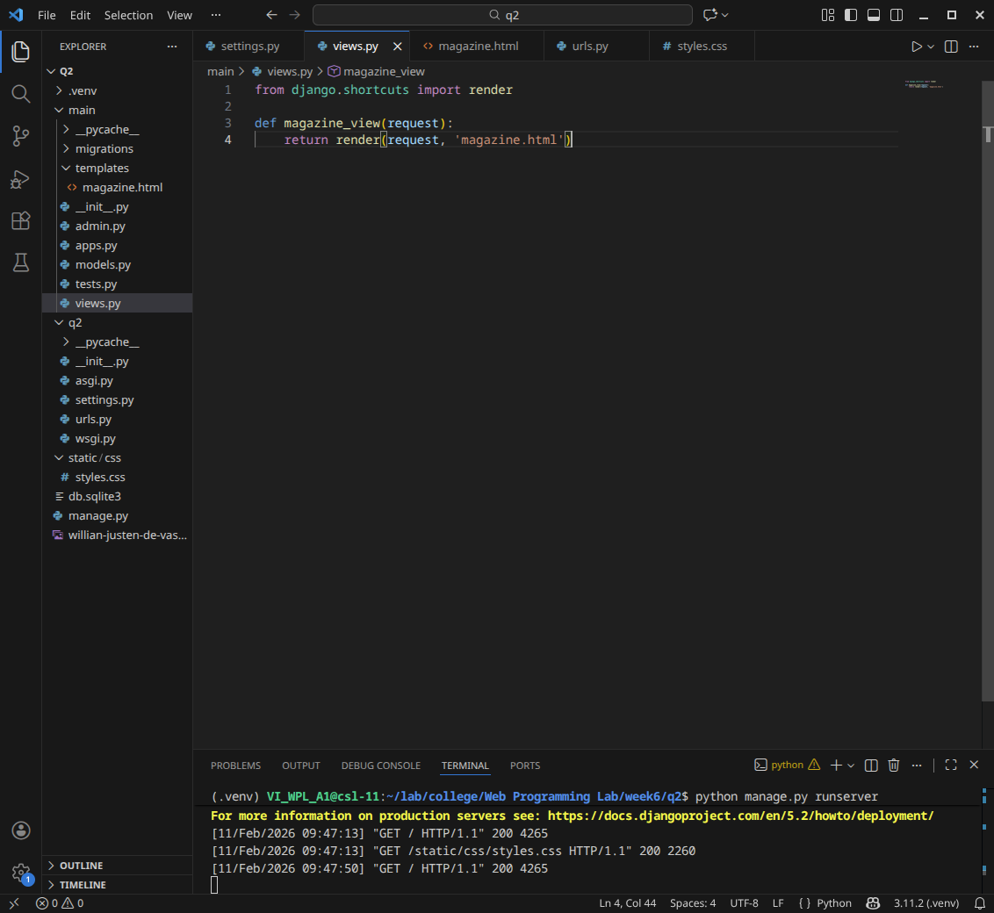Magazine.html

{% load static %}

<!DOCTYPE html>

<html lang="en">

<head>

<meta charset="UTF-8">

<meta name="viewport" content="width=device-width, initial-scale=1.0">

<title>Magazine Cover Generator</title>

<link href="https://fonts.googleapis.com/css2?family=Playfair+Display:wght@700;900&family=Roboto:wght@300;400;700&display=swap" rel="stylesheet">

<link rel="stylesheet" href="{% static 'css/styles.css' %}">

</head>

<body>

<div class="main-container">

<div class="controls-panel">

<h2>Cover Editor</h2>

<form id="magazineForm">

<div class="control-group">

<h3>Background</h3>

<label>Upload Image</label>

<input type="file" id="imgInput" accept="image/*">

<label>Background Color</label>

<input type="color" id="bgColor" value="#ffffff">

</div>

<div class="control-group">

<h3>Masthead (Title)</h3>

<label>Title Text</label>

<input type="text" id="titleText" value="VOGUE">

<label>Font Color</label>

<input type="color" id="titleColor" value="#ff0000">

<label>Font Size</label>

<input type="range" id="titleSize" min="40" max="150" value="100">

</div>

<div class="control-group">

<h3>Headlines</h3>

<label>Main Headline</label>

<input type="text" id="headlineText" value="SUMMER VIBES">

<label>Sub-Headline</label>

<input type="text" id="subHeadlineText" value="The ultimate guide to style">

<label>Text Color</label>

<input type="color" id="featureColor" value="#ffffff">

</div>

</form>

</div>

<div class="preview-panel">

<div id="magazineCover" class="magazine-cover">

<div class="overlay" id="coverOverlay"></div>

<h1 id="displayTitle">VOGUE</h1>

<div class="feature-content">

<h2 id="displayHeadline">SUMMER VIBES</h2>

<p id="displaySubHeadline">The ultimate guide to style</p>

</div>

<div class="issue-info">

<p>SEPT 2026 • $10.00</p>

<div class="barcode">||| || |||| | ||</div>

</div>

</div>

</div>

</div>

<script>

// Live Preview Logic

const imgInput = document.getElementById('imgInput');

const magazineCover = document.getElementById('magazineCover');

// Title Controls

document.getElementById('titleText').addEventListener('input', e => document.getElementById('displayTitle').innerText = e.target.value);

document.getElementById('titleColor').addEventListener('input', e => document.getElementById('displayTitle').style.color = e.target.value);

document.getElementById('titleSize').addEventListener('input', e => document.getElementById('displayTitle').style.fontSize = e.target.value + 'px');

// Headline Controls

document.getElementById('headlineText').addEventListener('input', e => document.getElementById('displayHeadline').innerText = e.target.value);

document.getElementById('subHeadlineText').addEventListener('input', e => document.getElementById('displaySubHeadline').innerText = e.target.value);

document.getElementById('featureColor').addEventListener('input', e => {

document.getElementById('displayHeadline').style.color = e.target.value;

document.getElementById('displaySubHeadline').style.color = e.target.value;

});

// Background Controls

document.getElementById('bgColor').addEventListener('input', e => magazineCover.style.backgroundColor = e.target.value);

// Image Upload Logic

imgInput.addEventListener('change', function(event) {

const file = event.target.files[0];

if (file) {

const reader = new FileReader();

reader.onload = function(e) {

magazineCover.style.backgroundImage = `url(${e.target.result})`;

};

reader.readAsDataURL(file);

}

});

</script>

</body>

</html>

Urls.py

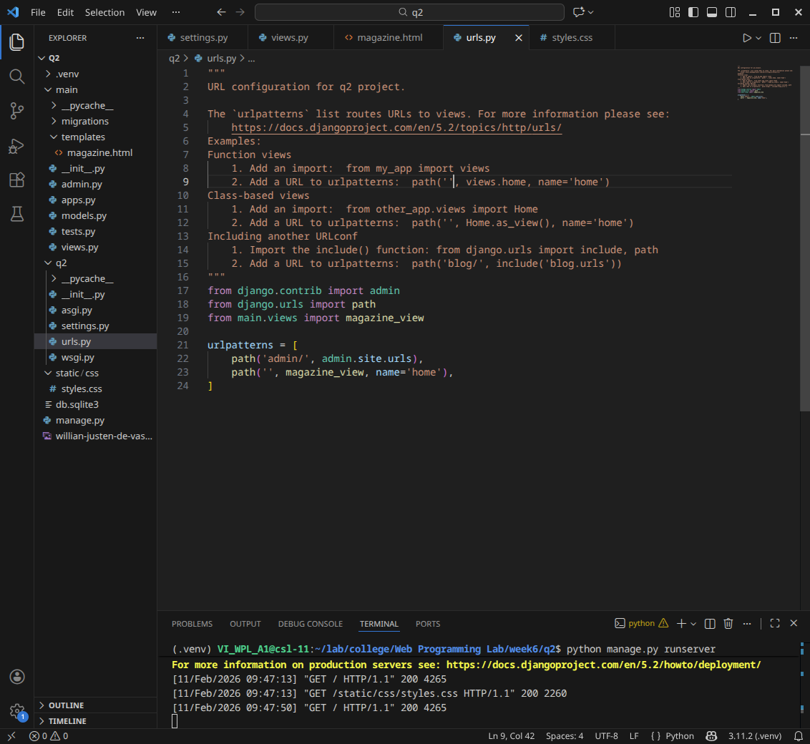Styles.css

body {

margin: 0;

font-family: 'Roboto', sans-serif;

background-color: #222;

height: 100vh;

display: flex;

align-items: center;

justify-content: center;

}

.main-container {

display: flex;

width: 95%;

max-width: 1200px;

height: 90vh;

background: white;

border-radius: 10px;

overflow: hidden;

}

/* Controls Panel (Left) */

.controls-panel {

flex: 1;

padding: 20px;

background: #f4f4f4;

overflow-y: auto;

}

.control-group {

background: white;

padding: 15px;

margin-bottom: 15px;

border-radius: 5px;

box-shadow: 0 2px 5px rgba(0,0,0,0.05);

}

label {

display: block;

font-size: 0.85rem;

margin: 10px 0 5px;

font-weight: bold;

color: #555;

}

input[type="text"], input[type="file"] {

width: 100%;

padding: 8px;

border: 1px solid #ddd;

box-sizing: border-box;

}

/* Preview Panel (Right) */

.preview-panel {

flex: 1.5;

background: #333;

display: flex;

justify-content: center;

align-items: center;

padding: 20px;

}

.magazine-cover {

width: 100%;

aspect-ratio: 1 / 1.4; /* Magazine Ratio */

max-height: 100%;

background-color: white;

background-size: cover;

background-position: center;

position: relative;

display: flex;

flex-direction: column;

justify-content: space-between;

box-shadow: 0 0 20px rgba(0,0,0,0.5);

}

/* Typography on Cover */

#displayTitle {

font-family: 'Playfair Display', serif;

font-size: 100px;

text-align: center;

margin: 0;

line-height: 0.9;

z-index: 2;

text-shadow: 2px 2px 10px rgba(0,0,0,0.3);

}

.feature-content {

padding: 20px;

margin-top: auto;

z-index: 2;

}

#displayHeadline {

font-size: 3rem;

text-transform: uppercase;

margin: 0;

line-height: 1;

text-shadow: 2px 2px 5px rgba(0,0,0,0.5);

}

#displaySubHeadline {

background: rgba(0,0,0,0.6);

color: white;

display: inline-block;

padding: 5px 10px;

margin-top: 10px;

}

.issue-info {

display: flex;

justify-content: space-between;

padding: 10px 20px;

background: white;

font-size: 0.8rem;

font-weight: bold;

}

.barcode {

font-family: monospace;

letter-spacing: -2px;

}

Website

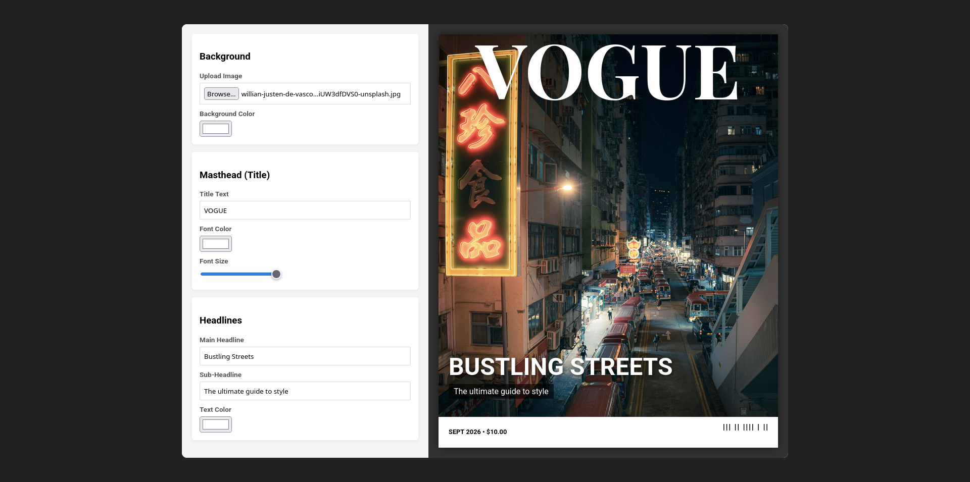Q3. Design a simple web application to provide information about a book. The

home page of the application should display the cover page of the book along

with three hyperlinks: Metadata, Reviews, Publisher info. Give provision to

revert to home page from any other page.

Urls.py

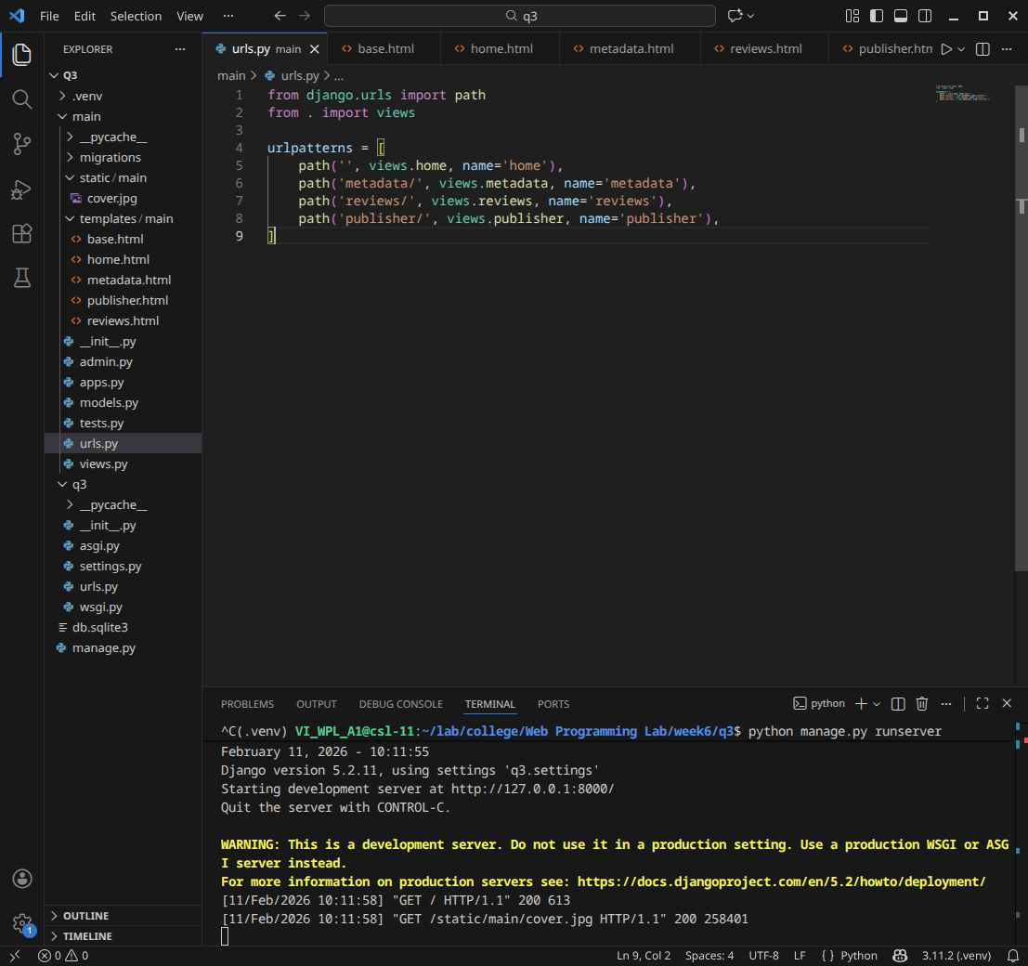Base.html

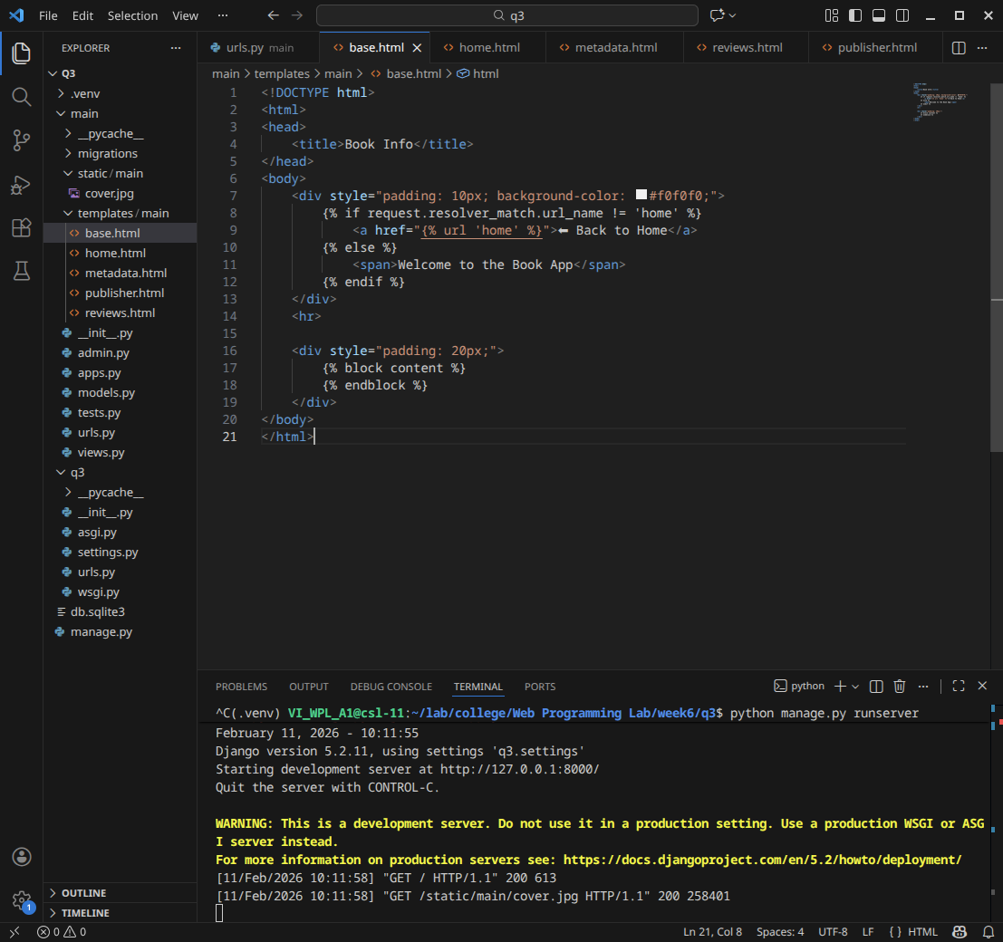Home.html

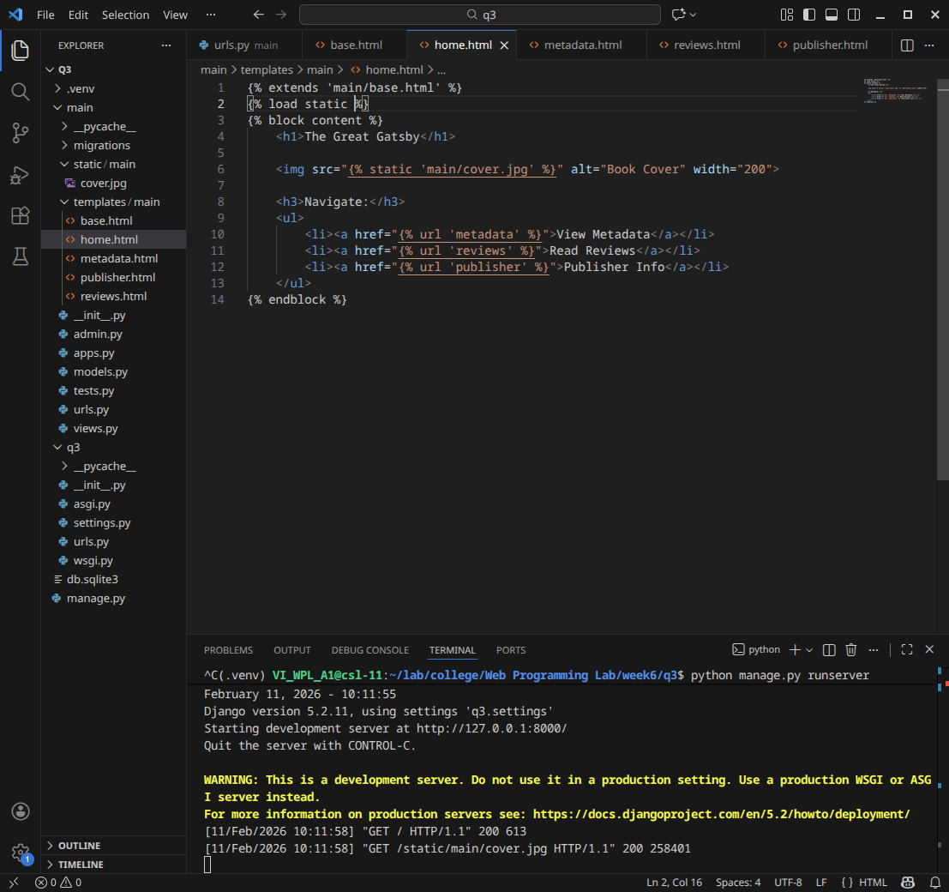Metadata.html

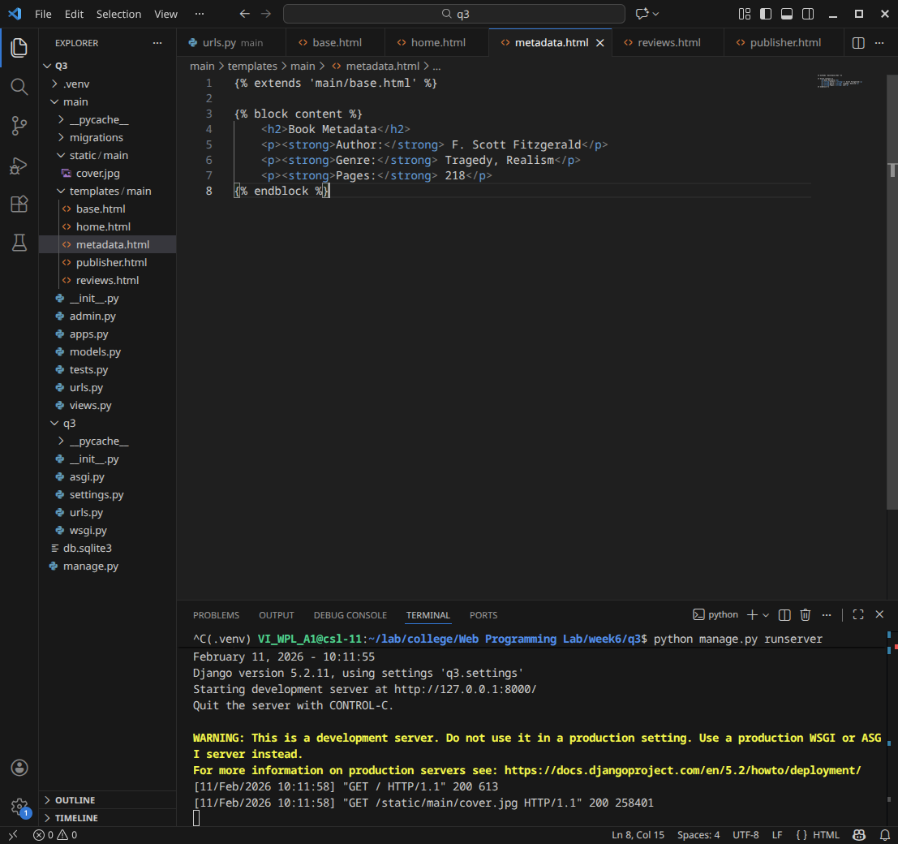Reviews.html

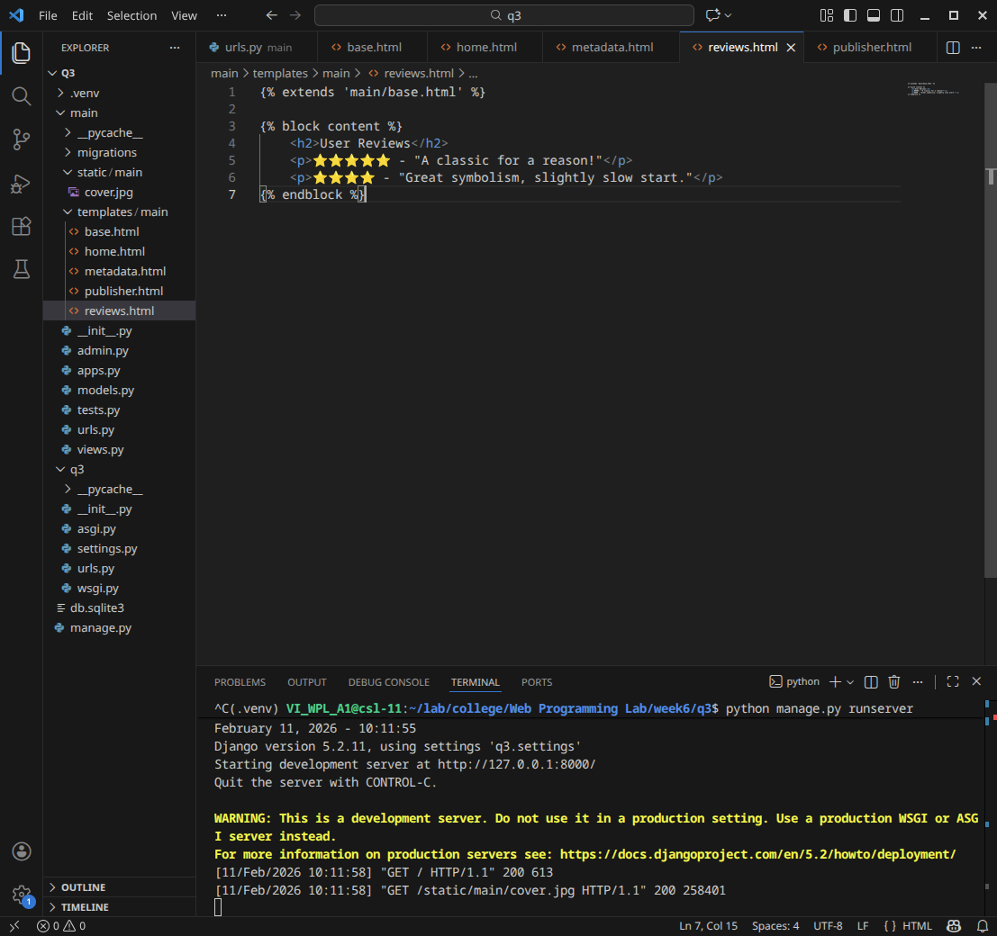Publisher.html

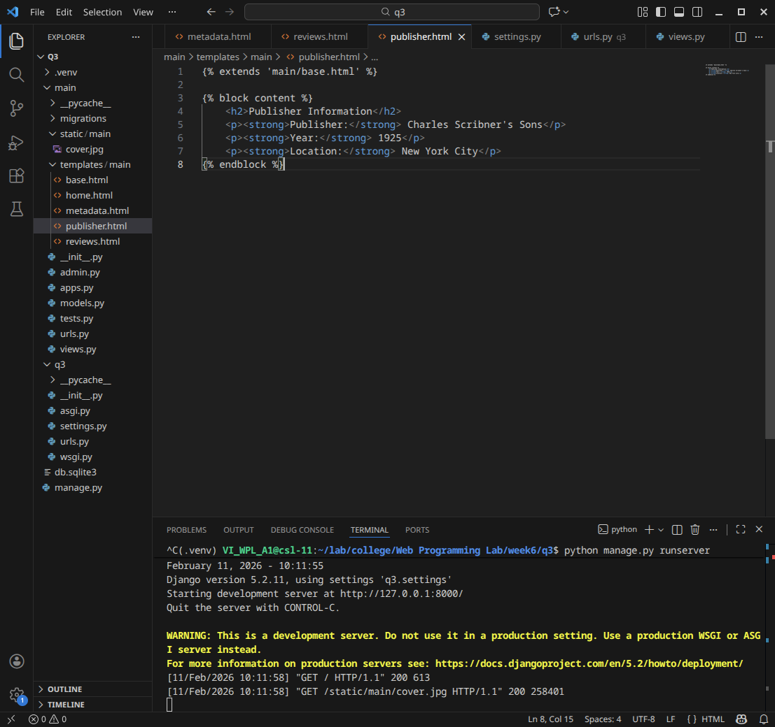Settings.py

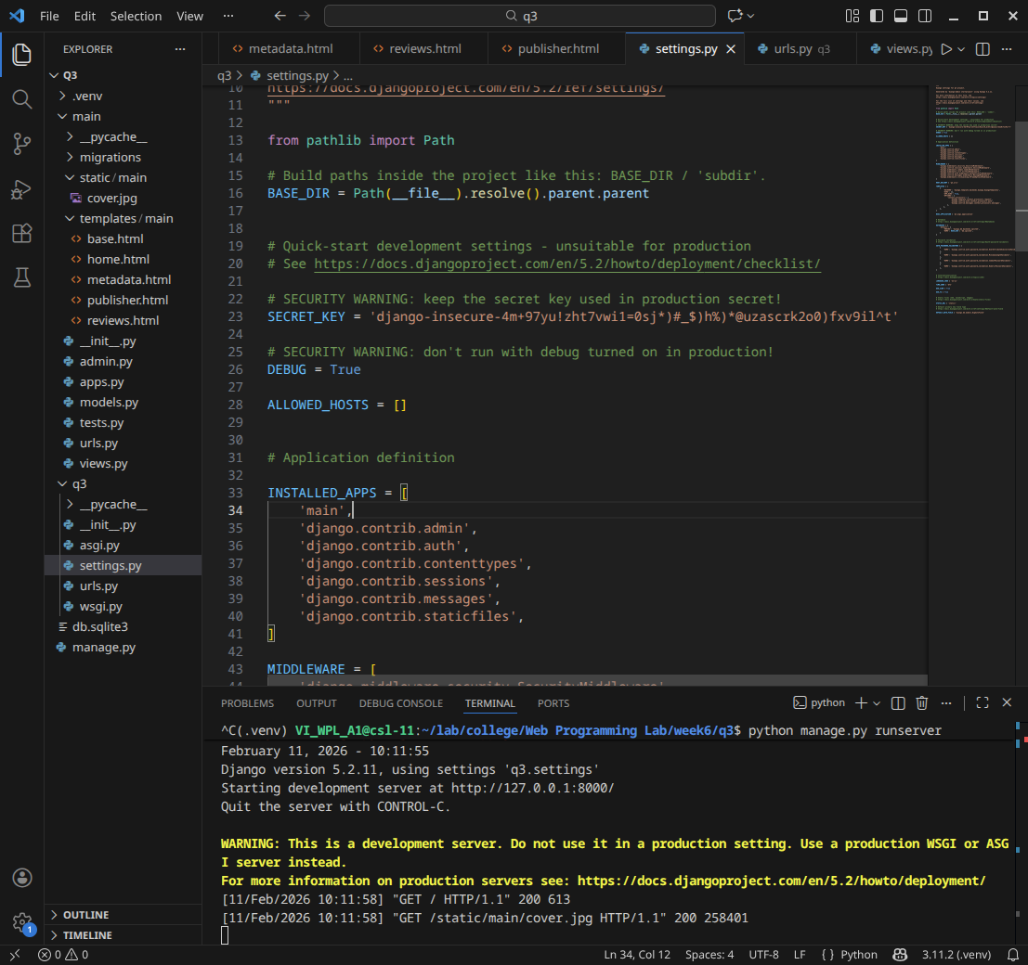Q3/urls.py

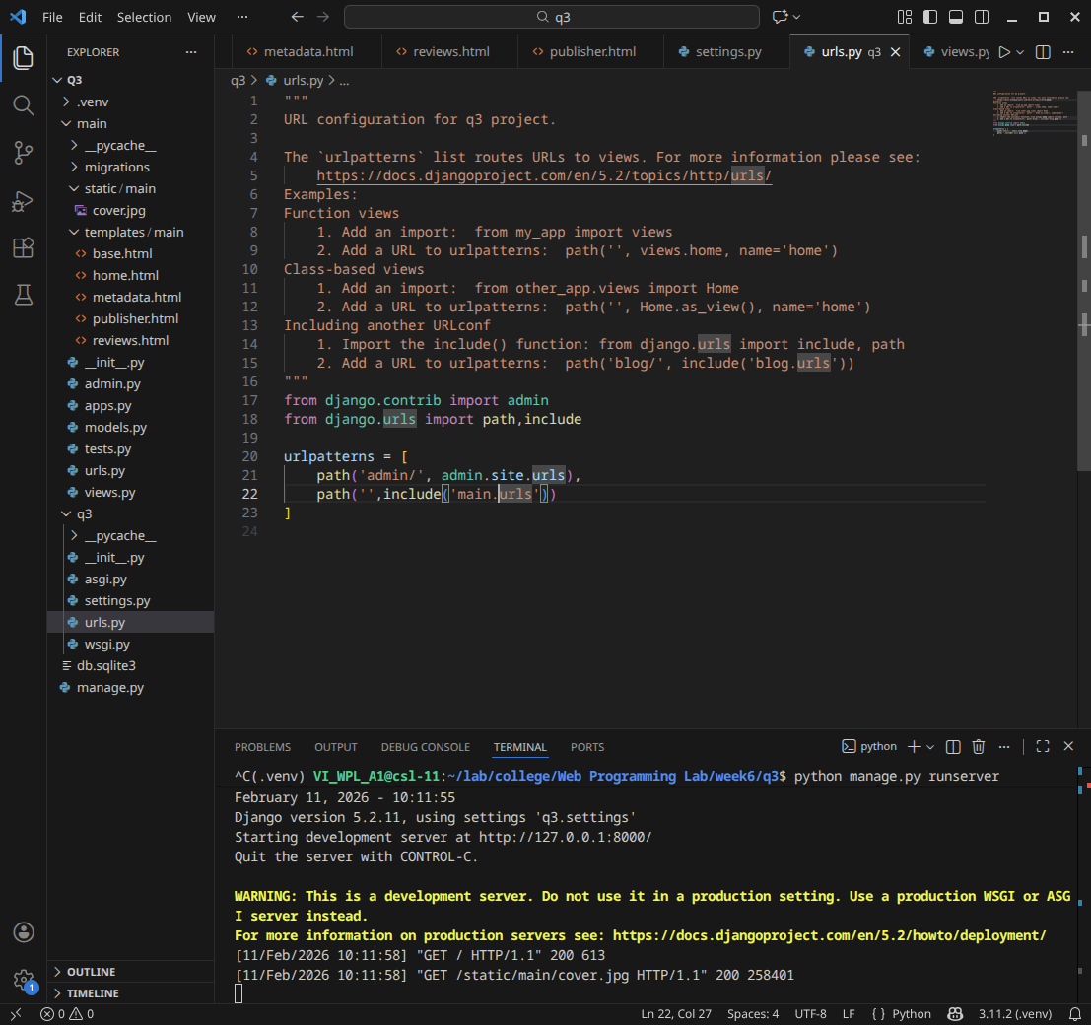View.py

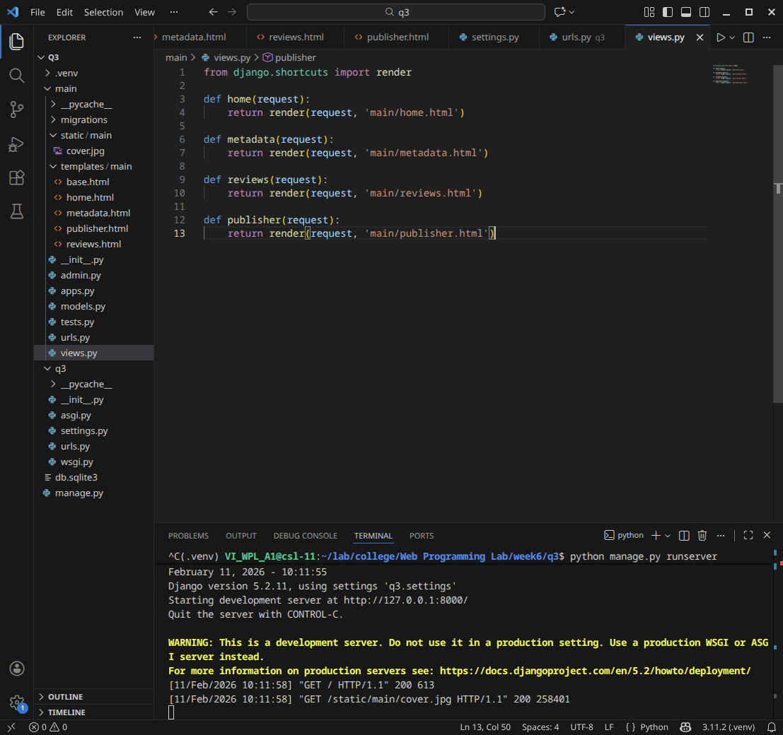Website

